1.

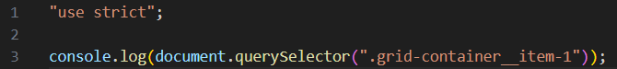



2.



3.

4.



5.



6.

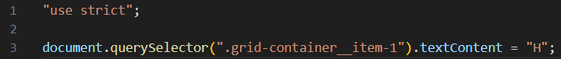

7.

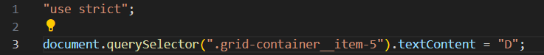

8.

9.

10.

11.



12.



13.

14.

15.

16.

17.

18.

19.

20.

